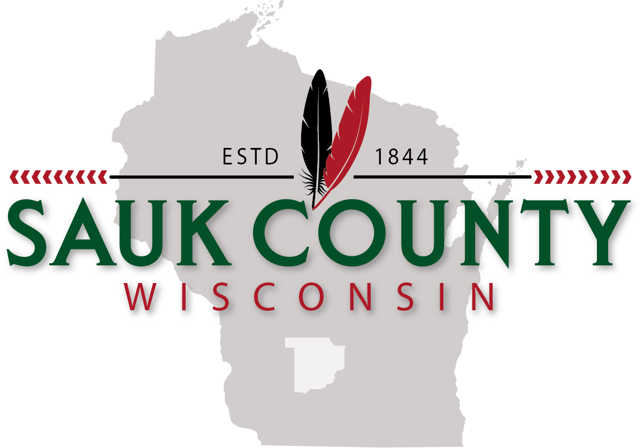 Peter Vedro
Sauk County Board Chair
West Square Building
505 Broadway, Rm. 140, Baraboo WI 53913-2183
Office: 608-355-3500 Cell: 608-963-6581

July 28, 2026

Grant Manager
NextGen 911 Grant
Wisconsin Department of Military Affairs
interop@wisconsin.gov

Re: Letter of Commitment for the Federal NextGen9-1-1 Reimbursement Grant Program

To whom it may concern:

I am writing to express my support for Sauk County’s NextGen 911 grant application to upgrade the current 911 system hardware at the Sauk County PSAP.

The Sauk County PSAP is the 911 point of contact for all emergency 911 calls in Sauk County, providing emergency communications for all first responders and dispatch services for local law enforcement.

The Sauk County Board has appropriated $125,000, from local tax levy, in the 2020 Sauk County Budget to support the upgrade of the 911 system hardware, which will be end of life in 2021. If Sauk County receives this funding, it will enable us to perform the upgrade during the 2020 fiscal year.

The Sauk County Board and staff will work collaboratively to ensure funding is utilized in a manner consistent with the requirements of the grant, including the provision of any necessary reporting. Implementation of this project will significantly improve the NextGen 911 capabilities of Sauk County’s PSAP and position Sauk County to provide advanced 911 communications into the future.

Thank you for your consideration.

Sincerely,

Peter Vedro,
Sauk County Board Chair

