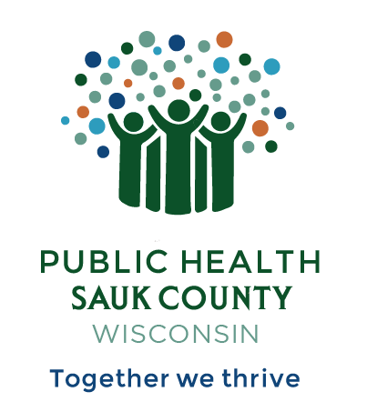
Public Health Sauk County
505 Broadway Street, Suite 372
Baraboo, WI 53913
Telephone: (608) 355-3290 Fax: (608) 355-4329

For immediate release May 6, 2024
Contact: Jodie Molitor, Health Educator
Public Health Sauk County
(608) 355-3290
Jodie.molitor@saukcountywi.gov

May is Mental Health Awareness Month
Sauk County, Wis— May is Mental Health Awareness Month. This month is a time to discuss how mental health is an important part of our overall health and well-being. Struggling with your mental health is not a sign of weakness, and you are not alone.
Last year, the Sauk County Health & Wellness Steering Committee partnered with CredibleMind to help provide free and confidential access to mental health and well-being resources. Whether you are experiencing anxiety or depression, want to tackle that “something-isn’t-right” feeling, or want to support your current level of well-being, CredibleMind has resources to get you started on your self-care journey.
Using CredibleMind, you can access:
- Over a dozen scientifically proven assessments that help you understand your mental health. These assessments cover topics like anxiety, depression, loneliness, substance use, and more.
- Thousands of expert-reviewed apps, podcasts, books, articles, and videos across hundreds of mental health topics.
- Tools that help you focus on building skills to thrive mentally and emotionally at work, with your family and friends, and in your community.
“Credible Mind is an amazing site filled with expert-reviewed resources to help get you through a rough patch, identify a problem that might need further evaluation by a professional, or simply help maintain good mental health,” says Jessie Phalen, Nurse Manager for Public Health Sauk County. “There is literally something for everyone here.”
Get started today at https://saukcounty.crediblemind.com/.
Special thanks to Sauk Prairie Healthcare and SSM Health St. Clare Hospital-Baraboo for their continued support in making CredibleMind available to Sauk County.
If you or someone you know is struggling or in crisis, help is available. Call or text 988 or chat at 988lifeline.org.
About Public Health Sauk County
Public Health Sauk County supports the well-being of all people in our community. Through wellness programs, environmental health initiatives, and a focus on creating systemic change, we cultivate healthier places and people so that Sauk County can thrive. For more information on our programs and services, visit https://www.co.sauk.wi.us/publichealth.
###

