**Public Health** **Sauk County**

505 Broadway Street, Suite 372

Baraboo, WI 53913

Telephone: (608) 355-3290 Fax: (608)355-4329

**For immediate release May 29, 2024**

Contact: Rebecca Szydlowski, Public Health Nurse

Sauk County Health Department

(608) 355-4337 [Rebecca.Szydlowski@saukcountywi.gov](mailto:Rebecca.Szydlowski@saukcountywi.gov)

**Public Health Sauk County Holds Rural Safety Day Camp**

Public Health Sauk County hosted their annual Rural Safety Day Camp at the Sauk County Fairgrounds on May 14th, 15th, and 16th. This year’s event covered the following safety topics: chemical, fire, electrical, gun, farm equipment, small/large animal, water, bike, seat belt, and ATV/UTV safety. Approximately 720 third-grade students attended the event.

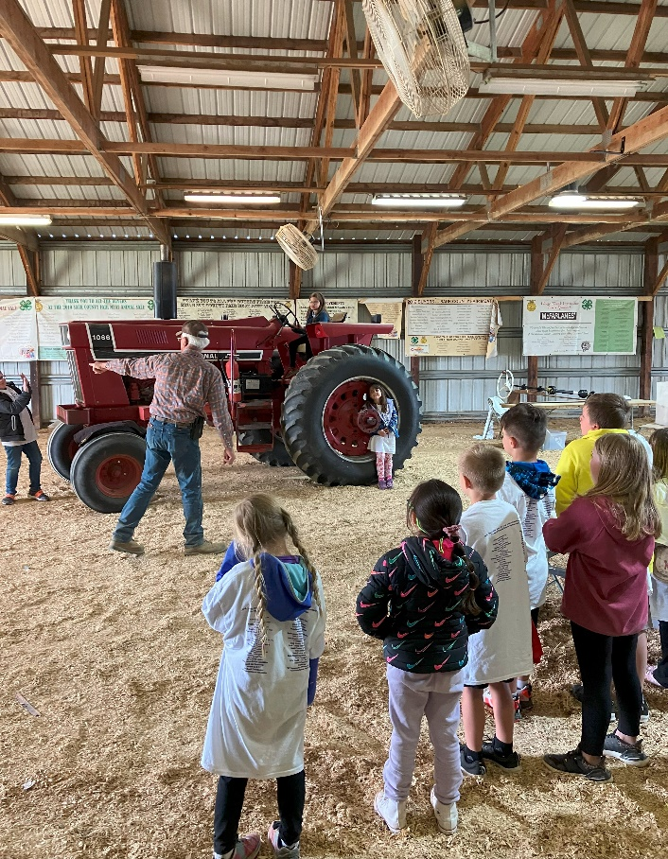Rural Safety Days is just one way the Safe Kids Sauk County Coalition works to prevent childhood injuries. The coalition also offers free car seat safety checks, provides safety items throughout the year when available, and more.

Figure : John Gerike presents to local 3rd graders on tractor safety.

“Rural Safety Days would not be possible without the generous donations and support from our numerous sponsors,” says Public Health Nurse Rebecca Szydlowski, who serves as the Rural Safety Days Coordinator. “We believe prevention is the best medicine and are so thankful for their support.”

Sponsors include: Allen Steele Company, Inc.; Alliant Energy; Baraboo Fire and EMS District; Baraboo FFA; Baraboo Police Department; Baraboo School District- Indoor Pool; Compeer Financial; Culvers; D. L. Gasser Construction; Downtown Family Dental of Baraboo, SC; Farm & Fleet of Baraboo; Fire and EMS Chiefs Association; Gerike Farms; Hartje Lumber; Hill-Dale Veterinary Hospital; Hillsboro Equipment; Jay’s Ag and Turf; Jay’s Power Center; Lake Delton Police Association; Lands’ End Reedsburg; Meyer Oil & LP; McReath Orthodontics; Mittelstaedt Sports and Marine; Morning Glory Veterinary Care; Prairie Clinic; Public Health Sauk County; Redlin-Ertz Funeral Home; Reedsburg Area Medical Center; Reedsburg FFA; Sauk County Emergency Management; Sauk County Fairgrounds; Sauk County Association Home and Community Education; Sauk County Humane Society; Sauk County Sheriff’s Department; Sauk County UW Extension; Sauk Prairie FFA; Sauk Prairie Healthcare; Sauk Prairie Healthcare Foundation; Scott Construction; SSM Health – St Clare Hospital; United Cooperative; Vierbicher; Viking Express Mart Reedsburg; WI Department of Natural Resources; WI Department of Transportation; and Wisconsin Metals, Reedsburg.

For more information about Safe Kids Sauk County or resources specific to Sauk County, please visit <https://www.co.sauk.wi.us/publichealth/safe-kids> or contact Rebecca Szydlowski, Safe Kids Sauk County Coalition Coordinator, at [rebecca.szydlowski@saukcountywi.gov](mailto:rebecca.szydlowski@saukcountywi.gov) or 608-355-4337.

**About Public Health Sauk County**

Public Health Sauk County supports the well-being of all people in our community. Through wellness programs, environmental health initiatives, and a focus on creating systemic change, we cultivate healthier places and people so Sauk County can thrive. For more information on our programs and services, visit <https://www.co.sauk.wi.us/publichealth>.

###