
Public Health Sauk County
505 Broadway Street, Suite 372
Baraboo, WI 53913
Telephone: (608) 355-3290 Fax: (608) 355-4329

For immediate release June 11, 2024
Contact: Jennifer Weitzel
Title: Interim Director/Health Officer
Public Health Sauk County
608-963-9178 Jennifer.weitzel@saukcountywi.gov

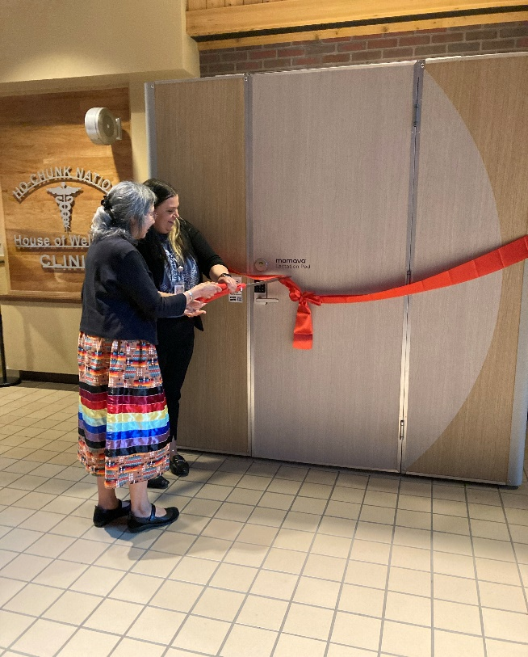
Public Health Sauk County and Ho-Chunk Nation celebrate the installation of lactation space

Sauk County, Wis— Public Health Sauk County, in partnership with the Ho-Chunk Nation, celebrated the installation of a Mamava® Lactation Pod at the Ho-Chunk House of Wellness on Monday, June 3rd, with a ribbon-cutting ceremony. The pod serves as a private space for breastfeeding and/or pumping for visitors and employees of the facility.
“Breastfeeding support is a key service we provide because of how beneficial it is to families,” says Kandyce Dunlap, Public Health Director for the Ho-Chunk Nation. “Having this dedicated space is a reflection of partnerships and continued commitment to breastfeeding support.”
Figure 1: Kandyce Dunlap and Janice Rice at the Ribbon Cutting Ceremony for the Mamava® Lactation Pod at the Ho-Chunk House of Wellness.

Public Health Sauk County is looking to provide one local business or organization with a Mamava® Lactation pod. This funding is provided by the US American Rescue Plan Act of 2021 to the Wisconsin Department of Health Services. “We look forward to promoting the culture of breastfeeding in Sauk County with the placement of another Mamava® Lactation Pod.” Says Jennifer Weitzel, Interim Director/Health Officer for Public Health Sauk County. To learn more or apply, please visit https://www.co.sauk.wi.us/publichealth/apply-lactation-pod.

About Public Health Sauk County
Public Health Sauk County supports the well-being of all people in our community. Through wellness programs, environmental health initiatives, and a focus on creating systemic change, we cultivate healthier places and people so that Sauk County can thrive. For more information on our programs and services, visit https://www.co.sauk.wi.us/publichealth.
###

