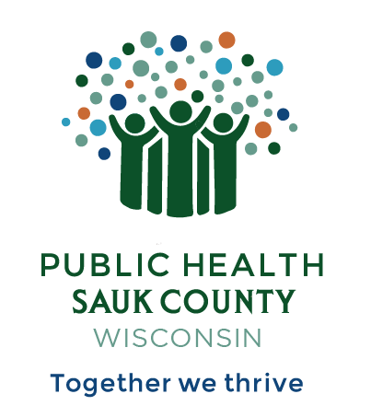
Public Health Sauk County
505 Broadway Street, Suite 372
Baraboo, WI 53913
Telephone: (608) 355-3290 Fax: (608) 355-4329

For immediate release June 27, 2024
Contact: Hannah Erdman, Health Educator
Public Health Sauk County
(608)-355-4319
Hannah.erdman@saukcountywi.gov

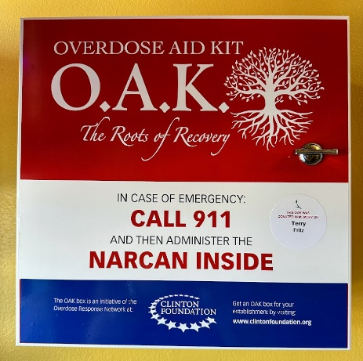
New Overdose Aid Kit installed in Spring Green
Sauk County, Wis -- Public Health Sauk County has partnered with the non-profit organization Start Healing Now to install an Overdose Aid Kit at Spring Green General Store in Spring Green.
Overdose Aid Kits or O.A.K.s are metal boxes that include Narcan - a U.S. Food and Drug Administration approved opioid overdose-reversal medication. The box also contains breathing masks, instructions for administering Narcan in an emergency, Dispose Rx Packets that provide a safe solution for the disposal of unused or expired medications, fentanyl test strips that can detect the presence of the powerful opioid fentanyl in different drugs, and local, state, and national resources for those struggling with substance use.
Figure 1: The front of the Overdose Aid Kit.
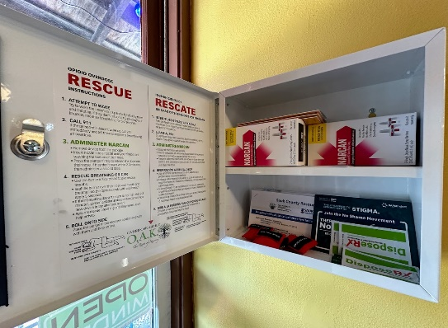
Karin Miller, owner of Spring Green General Store, stated, “We are happy to provide this service to the community, and are very impressed with the commitment shown by Start Healing Now. The Overdose Aid Kit and supplies are being provided at no charge and we put the box right by our front door to provide easy access for everyone. We are lucky to have such an active and far-reaching health department in Sauk County. I would encourage other businesses and community organizations to have an Overdose Aid Kit installed as well.”
Start Healing Now partners with other non-profits and organizations in Wisconsin to install Overdose Aid Kits for free. Jessica Geschke, Start Healing Now President, shared, “Start Healing Now is honored to provide these kits free to communities across the state of Wisconsin. This O.A.K. installed here at Spring Green General Store marks the 80th donation to a Wisconsin company free of charge by our organization and the 720th O.A.K. installation completed in Wisconsin in partnership with Start Healing Now, The Clinton Foundation and other local community partners.”
Figure 2: An inside view of the Overdose Aid Kit
Hannah Erdman, a Health Educator at Public Health Sauk County states, “Opioid overdoses can happen at any time and having Narcan on hand can save a life. The Narcan in the O.A.K. is available for anyone to take, no questions asked, and to use in an onsite emergency. We can all take action to save lives.”
If you are interested in having an Overdose Aid Kit installed at your location, contact Public Health Sauk County at 608-355-3290. You can learn how to use Narcan Nasal Spray to reverse an opioid overdose to save a life and get free Narcan at www.UCanSaveALife.org. To learn more about the Overdose Aid Kits please visit www.overdoseaidkit.com.
###

