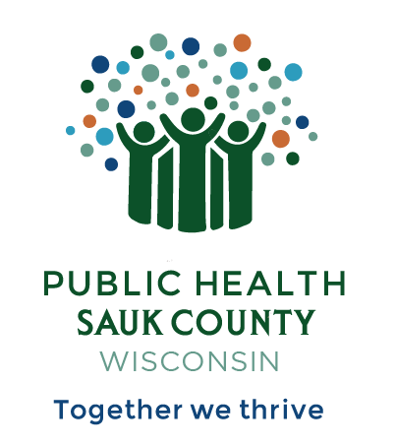
Public Health Sauk County
505 Broadway Street, Suite 372
Baraboo, WI 53913
Telephone: (608) 355-3290 Fax: (608) 355-4329

For immediate release July 16, 2024
Contact: Hannah Erdman, Health Educator
Public Health Sauk County
(608)-355-4319
Hannah.erdman@saukcountywi.gov

Sauk County Groups Host Free Community Event at Devil’s Lake on July 30th
Sauk County, Wis -- On Tuesday, July 30th, 2024, from 10 AM - 4 PM, Sauk County will host a free community event at Devil’s Lake State Park. The event is family-friendly, alcohol and drug-free, and is open to all Sauk County residents. The event will be held on the South Shore of Devil’s Lake State Park in the White Oak shelter.
“We are working to bring more family and recovery-friendly community events to Sauk County,” explains co-organizer Hannah Erdman, Health Educator with Public Health Sauk County and facilitator of the Support People and Empower Recovery coalition. “This is a great opportunity for family, friends, and neighbors to enjoy a day of fun in the sun at one of our beautiful state parks and meet people in our community. We will also have two people in recovery from substance use share about their recovery journey.”
Ben Miller, Case Manager for the Recovery Support Network program with Sauk County Justice, Diversion, and Support, provides details: “There will be time for hiking, swimming, games, fishing, and kayaking. We will also have live music in the afternoon by Alexander Gabriel. He will be performing from 12:30 PM - 1:30 PM. For lunch we will have free food and non-alcoholic beverages.”
Register for this free event at www.bit.ly/dayatdevilslake2024.
If you have any questions, please contact Hannah Erdman at hannah.erdman@saukcountywi.gov or call/text 608-963-8467.
This event is sponsored by Sauk County Justice, Diversion, and Support Programs, the Support People and Empower Recovery (SUPER) coalition, and Public Health Sauk County. This project is funded in part by a Healthy Community Partnership Grant from the SSM Health St. Clare Foundation. Bill Harris from People Helping People in Baraboo and other local businesses will donate food and beverages.
###

