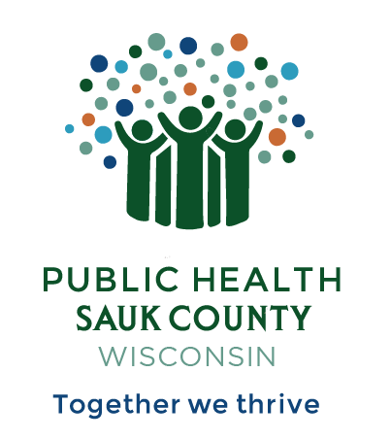
Public Health Sauk County
505 Broadway Street, Suite 372
Baraboo, WI 53913
Telephone: (608) 355-3290 Fax: (608) 355-4329

For immediate release October 1, 2024
Contact: Jennifer Weitzel
Title: Director/Health Officer
Public Health Sauk County
608-963-9178 Jennifer.weitzel@saukcountywi.gov

Nurse-Family Partnership at Public Health Sauk County Celebrates 10 Years of Success

Sauk County, Wis— Public Health Sauk County will be hosting an event to celebrate the tenth anniversary of Nurse-Family Partnership®, a national program serving first-time parents and their children impacted by economic inequality. Those enrolled in the program visit with a specially trained nurse beginning in pregnancy and continuing until the child turns two. The Nurse-Family Partnership program in Sauk County has served 336 clients in the last decade, with 155 graduates to date.
“Nurse-Family Partnership is a program with decades of proven success,” says Jennifer Weitzel, Health Officer at Public Health Sauk County. “We are proud to be positively impacting the lives of young families and the community as a whole with this program.”
To celebrate the program's success, there will be an event on Tuesday, October 8th, from 2 to 5 PM at the Carnegie-Schadde Memorial Public Library in Baraboo. The event will provide an opportunity to learn more about the program and its successes and meet the staff. Light refreshments will be served. If you would like to attend, please RSVP at https://bit.ly/SaukNFP10.

About Nurse-Family Partnership
Nurse-Family Partnership® serves first-time moms and their children affected by social and economic inequality throughout the first 1,000 days, from pregnancy until her child’s second birthday. The program annually serves nearly 55,000 families in 40 states, the U.S. Virgin Islands and many Tribal Communities. Nurse-Family Partnership is headquartered at the National Service Office for Nurse-Family Partnership and Child First, based in Denver, Colorado. Both programs work together to ensure that health care, early childhood development and the mental health of the entire family are delivered in proven ways to achieve long-term positive outcomes.
About Public Health Sauk County
Public Health Sauk County supports the well-being of all people in our community. Through wellness programs, environmental health initiatives, and a focus on creating systemic change, we cultivate healthier places and people so that Sauk County can thrive. For more information on our programs and services, visit https://www.co.sauk.wi.us/publichealth.
###

