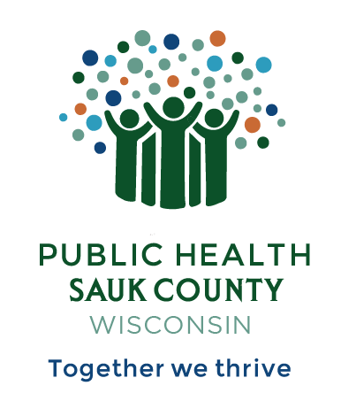
Public Health Sauk County
505 Broadway Street, Suite 372
Baraboo, WI 53913
Telephone: (608) 355-3290 Fax: (608) 355-4329

For immediate release December 26, 2024
Contact: Jessie Phalen
Title: Deputy Director
Public Health Sauk County
608-355-3290 jessie.phalen@saukcountywi.gov

Public Health Sauk County Partners with Grede Foundry to Install Lactation Space

Sauk County, Wis— Public Health Sauk County is pleased to announce that it has recently partnered with Grede Foundry to install a Mamava® Lactation Pod. This serves as a private space for breastfeeding and/or pumping for employees and features a comfortable seat, a shelf and outlet for a breast pump, a built-in fan for fresh air and white noise, and more. Caster wheels on the bottom allow moving the Lactation Pod to other spaces at the foundry if needed. Funds for this project were provided by the US American Rescue Plan Act of 2021 to the Wisconsin Department of Health Services.
“The addition of the Mamava® Lactation Pod at Grede Foundry is a great way to support lactating parents as they return to work,” says Jessie Phalen, Deputy Director at Public Health Sauk County. “In our search for a place to award the pod to, we learned that a common concern for parents who want to feed their baby breastmilk is where they will pump at work and whether it will be private and clean. We learned that many businesses offer a space, but sometimes it is not an ideal setup. Not all spaces are private, easy to access, or easy to keep clean, which can make it harder for a lactating parent to use those spaces. The Mamava® is a great answer to all these concerns.”
If you or someone you know would like to get involved with local breastfeeding initiatives, please contact Public Health Sauk County at 608-355-3290.
About Public Health Sauk County
Public Health Sauk County supports the well-being of all people in our community. Through wellness programs, environmental health initiatives, and a focus on creating systemic change, we cultivate healthier places and people so that Sauk County can thrive. For more information on our programs and services, visit https://www.co.sauk.wi.us/publichealth.
###

