**Public Health** **Sauk County**

505 Broadway Street, Suite 372

Baraboo, WI 53913

Telephone: (608) 355-3290 Fax: (608) 355-4329

**For immediate release February 27, 2025**

Contact: Michelle Bauer

Title: Nurse Supervisor

Public Health Sauk County, Nurse-Family Partnership®  
608-963-6115 [michelle.bauer@saukcountywi.gov](mailto:michelle.bauer@saukcountywi.gov)

**Sauk County Nurse-Family Partnership® Program Expands to Serve More Families and Children**

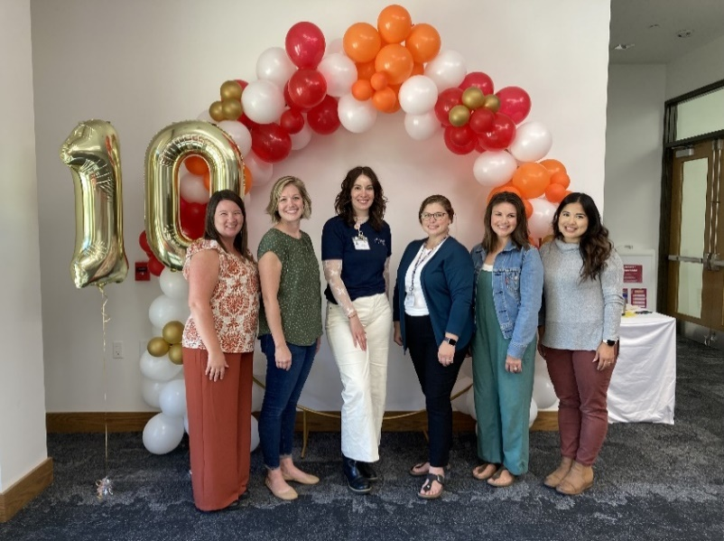**Sauk County, Wis—** The Sauk County Nurse-FamilyPartnership® program is excited to announce the program's expansion to serve more families and children. The program is now available for qualifying parents who already have children and are expecting another baby. This is a major change for the program, which previously only served first-time expecting parents before their third trimester began.

Nurse-Family Partnership® is a free program for any pregnant person who lives in Sauk County and qualifies for WIC or BadgerCare. Those who enroll are connected to a personal nurse who meets with the parent during pregnancy until the child turns two years old. The personal nurse works with the parent to help them:

The Sauk County Nurse-Family Partnership Nurses at the 10th Anniversary Celebration for the program that took place this past October. From left to right: Betsy Maston, Michelle Bauer, Sydney Troeller, Hannah Dobosz, Betsy McCaulley, and Angie Meise.

* Have a healthy pregnancy and a healthy baby
* Become a more confident parent
* Build a strong network of support for them and their baby
* Make the home a safe place for the baby to live and play
* Connect families to community resources
* Find ways to continue their education and develop job skills
* Set goals for their family's future and find ways to help them reach these goals

“Many pregnant people qualified for our program before but couldn't join because they already had children. Now they can,” says Michelle Bauer, Nurse Supervisor for the Sauk County Nurse-Family Partnership® program. "We're thrilled to offer our support to more families who need it in our community.”

To learn more about the Nurse-Family Partnership® program in Sauk County, please visit <https://www.co.sauk.wi.us/publichealth/nurse-family-partnership>.

**About Public Health Sauk County**

Public Health Sauk County supports the well-being of all people in our community. Through wellness programs, environmental health initiatives, and a focus on creating systemic change, we cultivate healthier places and people so that Sauk County can thrive. For more information on our programs and services, visit <https://www.co.sauk.wi.us/publichealth>.

###