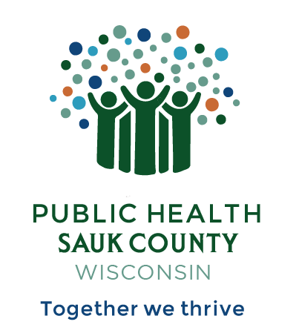
Public Health Sauk County
505 Broadway Street, Suite 372
Baraboo, WI 53913
Telephone: (608) 355-3290 Fax: (608) 355-4329

For immediate release March 25, 2025
Contact: Jessie Phalen, Deputy Director
Public Health Sauk County
608-355-3290 jessie.phalen@saukcountywi.gov

Public Health Sauk County to Host Showcase Event in Celebration of National Public Health Week
Sauk County, Wis— Public Health Sauk County invites everyone to attend its Public Health Showcase on Tuesday, April 8th, 2025, from 10 AM to 2 PM. The event will be held on the 3rd floor of the West Square Building in Baraboo, in the hallway outside the Health Department.
This showcase will highlight the department's current programs, services, and work to improve community health. Visitors can talk directly with public health staff, get helpful resources, and learn about efforts to address important health issues in Sauk County.
The event takes place during National Public Health Week (April 7-13, 2025) to celebrate the important work of public health professionals and raise awareness about health issues that impact Sauk County residents.
“I’m incredibly proud of our team’s achievements this year,” says Jessie Phalen, Deputy Director at Public Health Sauk County. “The Public Health Showcase is your opportunity to experience our work firsthand, connect with our staff, and discover resources that can improve health outcomes for your family. Join us on April 8th at the West Square Building to learn how our services can benefit you directly and make a lasting difference in your health and well-being.”
About Public Health Sauk County
Public Health Sauk County supports the well-being of all people in our community. Through wellness programs, environmental health initiatives, and a focus on creating systemic change, we cultivate healthier places and people so that Sauk County can thrive. For more information on our programs and services, visit https://www.co.sauk.wi.us/publichealth.
###

