WANTED

HOMICIDE

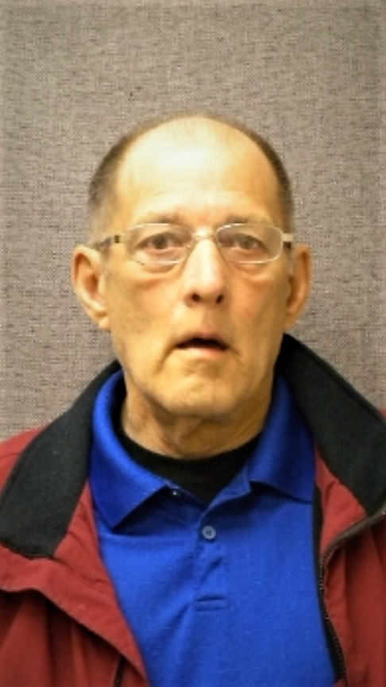

Robert Marcus Pulvermacher

08/09/1950

Pulvermacher is wanted for 1st Degree Intentional Homicide by the Sauk County Sheriff’s Office in Baraboo, WI. He was last seen in Madison, WI on Tuesday, January 15th, 2019. He is known to frequent Casinos in the Madison and Baraboo area. He is considered Armed and Dangerous. If located, do not make contact or attempt to apprehend him. Attempt to maintain visual and call 911. Any information regarding this crime or the whereabouts of Pulvermacher, please call Sauk County Crime Stoppers at 1-888-847-7285.